K.Mohammed Aathif

19001199

----------------------------------------------------------------------

(Day – 5)

----------------------------------------------------------------------

1. GET METHOD

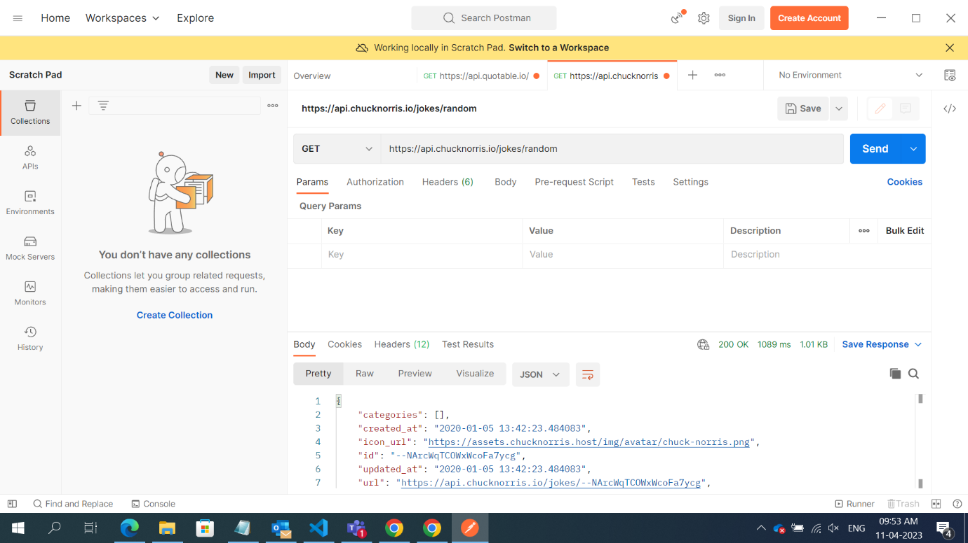

----------------------------------------------------------------------

1. PUT METHOD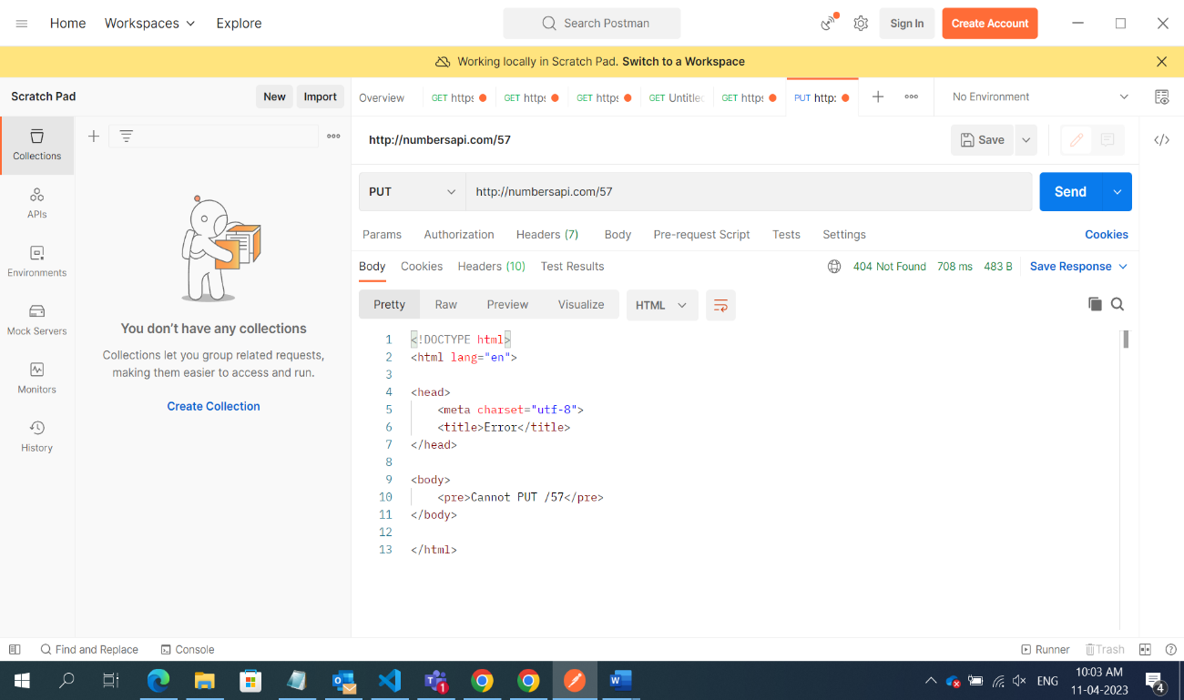
2. POST METHOD

1. GET METHODS



